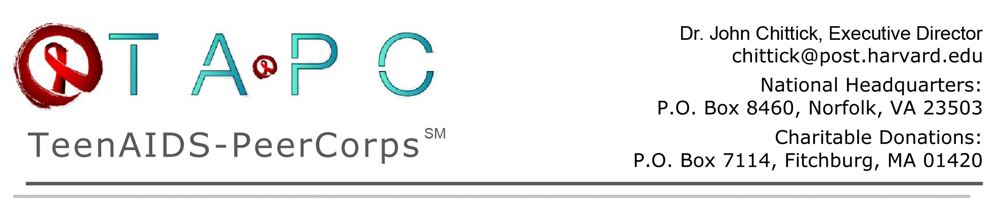

December 2, 2012
Dear John:
I am sitting here writing this note just a few hours after my team of volunteers and I sponsored the largest youth event in the country on World AIDS Day – over 400 high school and university students turned out for voluntary HIV and STI testing. With CDC statistics showing that 50% of new cases occur among ages 13 and 24, I am organizing this prevention campaign to fight a dangerous threat to the younger generation, some of whom are your family members and neighbors.
For six months now since the FDA approved over the counter sales, we have taken the national lead in promoting this revolutionary oral swab home test kits with accurate results in 20 minutes! Yet the stigma surrounding AIDS remains so great that most young people prefer not to know their status – even if it means they are transmitting HIV unknowingly to unsuspecting partners. Currently less than 92% of youth have ever been tested voluntarily. This new method of taking a bit of saliva in private, not blood by needle in a clinic where people see them, is easy and inviting.
So we are bringing teens to youth-friendly events where testing is offered. We tell them, “It is better to know” because medical help exists when diagnosed early on. I know very well how adolescents think. Once tested, they will tell their friends by Facebook, texts and Tweets, starting more conversations along the way; minimizing their risky behaviors and using protection. Don’t assume they don’t care. They do.
In the last 18 months, we have had a total of 90 college interns join our efforts putting in about 120 hours each per term (to the envy of more established non-profits). In June, we held a mega Car Wash along a busy thoroughfare where testing was publicly displayed and free. Young people stopped for the DJ’s music and the testing. In August we held a Sports Day where teens and youth organizations came to play basketball, volleyball, softball, hear the medical facts – and get tested.
But our December 1 “Hop Off for Teens” was spectacular. These youth not only gave willingly of their time but they paid a donation to participate. We sweetened the deal with hours of dance competition, live music and engaging information sessions. Amazingly, many waited in lines for up to 30 minutes waiting their turn. My only disappointment was that we ran out of the tests by mid-afternoon because of money.
Have you ever heard of this kind of response before? I doubt it; even AIDS organizers haven’t. This is ground-breaking work and I want to take it on the road, literally. For the last month, I have been the first person in the US walking the streets with test kits in hand asking teens if they are willing to be tested. So far, no one has tested positive but that day will come. And when it happens, I will use my expertise and training to counsel and take them to a hospital immediately for a confirmatory test and quickly

arrange for their medical treatment and follow up care. College students are joining in and being trained. I believe my innovative approach will soon catch the media’s attention and help us expand this outreach into a nationwide movement. The more public attention on rapid home testing means informed youth will take less risk.
The only drawback is the cost of the home kits. Currently one company has the monopoly and they are taking full advantage of the lack of any competition. I have been in contact with the FDA and federal lawmakers to rectify this situation so that competing pharmaceutical companies can quickly have their home tests join the free marketplace. I am also fighting a ridiculous rule that says only consumers 17 and older may buy home testing kits -- but who is to say that sexually active 16 year-olds (the age when the majority begin sex) shouldn’t have the right to buy kits and test their own bodies? Well, I believe they do and I am pushing hard to build a coalition to promote a realistic approach to educate and test at-risk youth because it can save lives.
I correctly predicted 20 years ago in my doctoral research that adolescents would be in the forefront of the millennium’s coming wave of HIV. Unfortunately, adult society has failed the current generation with its head in the sand approach. Today there is less school AIDS education -- at the very time when teens are more in danger than ever before -- than existed when many of you first heard about AIDS or were in school.
Help me and TeenAIDS help the young generation lead productive, healthy lives. We have just finished four years of a devastating recession that has crippled modest non-profits like TA-PC. This holiday season please think about donating to our small charity that is affecting major change at the grassroots. Your money is not going towards paying me a salary or for exorbitant overhead costs. I have cut the organization’s expenses to the bone (we operate on half of what we spent in 2007-2008). Your tax-deductible donation to TeenAIDS will do more for your buck than in top-heavy organizations with offices full of telemarketers and advertising gurus.
I soon turn 65. My idea of retiring to my South Pacific atoll at 67 is now on hold. My immediate goal is to train other teen organizations via social media how to throw these mega events at minimal cost (I beg, borrow but not steal) and set up a series of these entertainment and testing venues in 8 to 10 cities nationally in 2013/2014. I know how to do this well. I possess the creative organizational skills. I only need resources.
How about making a larger than usual donation this year? I want to do our first audit since 2006 so we can be eligible for major funding to finance my ambitious program. We have everything prepared to proceed but need the money. We need three new laptops. Test kits are expensive but if they save lives and stop the spread of HIV/AIDS, it’s worth every penny. My global walks continue as financing permits. Did you know that I am the only person who has trained teens to be peer HIV teachers on the streets of all six continents – 86 countries to date, a world record? I have the energy and the strength of purpose to continue to affect a real difference. Please join me.

Dr. John
It was an honor to make the final round of the Classy Awards’ “Volunteer of the Year.” If you were able to cast a vote, thank you!

